Chapter 16, Problem 20.

Find i(t) for t > 0 in the circuit of Fig. 8.43.

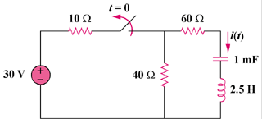
20V

Figure 16.43
For Prob. 16.20.

